**UNIT III -WEB ANALYTICS**

Web analytics

Web analytics is the gathering, synthesizing, and analysis of website data with the goal of improving the website user experience. It’s a practice that’s useful for managing and optimizing websites, web applications, or other web products.

The analysis of qualitative and quantitative data from your website and the competition, to drive a continual improvement of the online experience that your customers, and potential customers have, which translates into your desired outcomes (online and offline).

This definition encapsulates three main tasks every business must tackle when doing web analytics:

* Measuring quantitative and qualitative data
* Continuously improving your website
* Aligning your measurement strategy with your business strategy

Product managers, data scientists, UX designers and others can use web analytics if they’re looking to enhance their website or product experience to meet customer needs. They need to know which website metrics to track while also being mindful of the shortcomings of web analytics.

Importance of Web analytics:

1. Refine your marketing campaigns
2. Understand your website visitors
3. Analyse website conversions
4. Improve the website user experience
5. Boost your search engine ranking
6. Understand and optimize referral sources
7. Boost online sales

The process of web analytics

All of the data and analysis must drive a continuous improvement process. This is the most critical part of web analytics. You must take action on the data. That’s the whole purpose of web analytics—to improve over time.

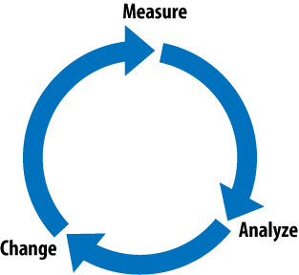

The process of web analytics involves:

**Setting business goals**: Defining the key metrics that will determine the success of your business and website

**Collecting data**: Gathering information, statistics, and data on website visitors using analytics tools

**Processing data:** Converting the raw data you’ve gathered into meaningful ratios, KPIs, and other information that tell a story

**Reporting data:** Displaying the processed data in an easy-to-read format

**Developing an online strategy**: Creating a plan to optimize the website experience to meet business goals

Key Metrics Web Analytics and User Experience

1. **Website Visitors**

Before you gauge how attractive and engaging your website is, you’ll need visitors, so the first metric you should track is the number of site visitors. Traffic data is usually one of the first metrics you use for every marketing strategy telling you how these users found your site, among tons of other information.

You can create content that ranks on search engines to get more visitors to your website, something that’s called organic search traffic. And you can get backlinks, that is, links to your website posted on other popular websites with the same kind of audience you’re trying to attract.

You can also attract more visitors by running ad campaigns on Google Ads and following our top Facebook marketing tips to excel at social media.

If you already have a well-established website that gets a lot of traffic, you should measure the return visitors or repeat visitors metric. Returning visitors are those who have visited your website at least once. Having a lot of return visitors is important because it shows that your content is engaging.

If you don’t have many return visitors, you can:

* Create more engaging content like infographics and videos
* Add more products to your store or improve existing product pages with better copy, attractive product pictures, and videos
* Choose a more suitable demographic to target in your ad campaigns

1. **Bounce Rate**

A person lands on a website from a search engine like Google. They look at the site and realize it doesn’t have the information, products, or services they’re looking for. So, they leave your website, adding to your website’s bounce rate!

There are multiple reasons why this happens. Maybe they think the site looks dull, or it’s just that people can’t find the information they’re after. In response, they click the back button on their browsers after a few seconds.

That is known as a visitor who has bounced. The ratio of the total website traffic to those who have bounced (left) is called a bounce rate.

A high bounce rate affects your SEO ranking and can make your site appear lower in search results, which can cause a significant drop in website traffic.

To tackle this issue, we must look at our bounce rate data. To do that, go to your Google Analytics page and find which web pages have the highest bounce rate.

Since the bounce rate is caused by a mismatch between visitor interest and the content on your website, there are three things you can do to improve it.

* You can enhance the content on your website so new visitors will be engaged and stay longer.
* You can refine your audience targeting to attract visitors interested in the products or services on your website.
* Read our in-depth analysis of how to reduce your website’s bounce rate.

**3. Average Pageviews per Session**

If you want to know how engaging your website is, this is the metric to pay attention to. The average pageviews per session show precisely how many pages of your website a visitor has browsed.

For example, if you operate an eCommerce store, you want visitors to browse as many products as possible before eventually buying. If the average pageviews are five pages, you can assume that people typically look at three products per session – the first two pages are most likely the homepage and product category page.

To improve this metric, you must add as much compelling content to your website as possible. Usually, this means adding a “people also look at this” section based on the customer’s previous orders or by following other user behaviours.

One thing to remember is that a high average pageviews per session score doesn’t guarantee an increased number of subscribers or customers, but it’s a good indicator. The more pages visitors see on your website, the more likely they’ll take the action you want.

**4. Average Session Duration**

The average session duration metric is fairly simple. It calculates how much time a visitor was active on your website. Like the average pageviews per session, this metric is an excellent indicator of your website’s engagement. The more clicks your website gets, the higher this metric will be.

But remember that the average session duration isn’t reliable if your website isn’t based on interactions. If a user is inactive for 30 minutes or more, for example, the user isn’t clicking, Google Analytics will consider that their session has ended.

Suppose your website is focused on showcasing the products and services you sell and depends on people exploring its web pages and links. In that case, the session duration could be a more precise indicator of how attractive people find your website.

On the other hand, if you publish in-depth blog articles or super-long videos on your website, your visitors might only click a few pages. In that case, this metric wouldn’t be reliable for measuring engagement.

**5. Average Time on Page**

This is another of the many website engagement metrics. When considered with average session time, the metric that shows your actual engagement is the average time on the page.

The average time on page metric shows how much time is spent on your website’s pages. If you sell products, you’ll want people to look at product pages more than your landing page or product categories page.

The average time on page will let you know which kinds of pages visitors are spending more time on. This is particularly useful for content-heavy websites that depend upon visitors reading articles and watching videos.

**6. Top Traffic Sources**

There are places your website visitors come from, A traffic source shows from what medium your visitors come from. Is it a search engine, social media, email, or paid search? That can be answered by looking at your traffic sources in your analytics tool.

For example, if you have an active Instagram page promoting your website’s products or a YouTube channel where you create supplementary how-to videos, these are considered traffic sources. When many visitors come to your website from a particular source, that is one of your top traffic sources.

Why are traffic sources important?

Because they help make sense of other data on your website. For example, suppose your average session time is two minutes and 30 seconds. If you drill down and look at the traffic source associated with that session time data, you’ll get some precious insight.

Your average session time from newsletter subscribers might be three minutes and 15 seconds, while the one from Facebook might be just 30 seconds.

By looking at the average session time per traffic source, you found that your email subscribers love engaging with your website more than visitors from Facebook.

They are valuable, but you need to use them in tandem with other metrics, like traffic sources, for them to make much more sense. When combined with other metrics, these “averages” can help you determine where your website’s engagement is coming from.

**7. Device Source**

Device source is another metric you can use as input when trying to make your website more engaging.

This metric can be used to find the top device types (PC, tablet, or smartphone) people use to access your website. In addition, you can see the top operating systems (iOS, Android, Windows, and macOS) and top browsers (Chrome, Safari, Firefox, and Edge) being used to render your site.

Knowing this will allow you to optimize your website for the kind of devices it’s being accessed from. Looking at the current landscape, it’s fair to say that most people use their smartphones a lot when browsing online, which means you must pay as much attention to them as desktop users.

Designing and checking if your website is mobile-friendly is a more straightforward process

8**. Interactions per Visit**

The interactions per visit metric is another fantastic metric you should monitor on your site. It shows how visitors are moving across your website, again giving you an in-depth look at which parts of your website are engaging and which aren’t.

For example, in an online store, you can see which product category page people visit the most or the least. Knowing this will tell you what kind of products your visitors are interested in seeing. This is excellent when planning your next shipment, as you’ll know precisely what drives people to your online store.

The interactions per visit metric also let you see the exact link, button, or other interactive elements a visitor has clicked and what action they took, for instance, what they liked, bought, commented on, or subscribed.

**9. Exit Pages and Top Exit Pages**

Many sites have a multi-step conversion process. For example, if you’re selling products via content marketing, you’ll first want visitors to read an article based on that product. Then you’ll want them to go to your eCommerce store and buy that product. Maybe you also want them to subscribe to your blog to learn more about the next exciting product your company sells.

Your visitors may have to click on a purchase link via email and fill out a form, among other things.

In an eCommerce store, visitors may have to search for an item via the search bar or an extensive product category menu, click the checkout button, complete the checkout form, and pay for the item. This user journey includes multiple pages, but it can have some issues.

Visitors can fall out of touch at any point in a process with multiple pages like this. It may be because the entire process needs to be simplified or because the visitor changed their mind regarding the product they’re buying.

which of your website’s pages are exit pages: pages where people are abandoning your website.

Although exit pages have a lot in common with the bounce rate that we discussed earlier. If you’re an eCommerce store owner, some exit pages, like a “thank you for your purchase” or “thanks for contacting,” are expected and don’t count towards your bounce rate.

If a visitor goes through four or five web pages before leaving your website, the last page they visited will count towards your exit page rate. Google thoroughly explains the subject and how it differs from the bounce rate discussed earlier.

**10. Conversion Rate**

More specifically, the conversion rate displays the percentage of people who complete a specific task or action on your website. You can evaluate your conversion rate by looking at your call-to-action buttons (CTAs) and their placement on your landing pages.

Your conversion rate isn’t driven entirely by your content but also by the website’s design and structure. By ensuring your website is well-designed with clean landing pages and CTAsb(**call to action** ), you’re creating the basis to increase conversions and boost your sales.

All metrics matter. And while all the information you get from the tracking tools is a goldmine, you should also know how to fill the gaps between them, painting a clearer picture of how your website’s doing.

That’s where event tracking comes in handy. Event tracking is probably one of the most crucial website metrics, leveraging custom events that most tracking tools don’t measure. For instance, in Google Analytics, you can label each event to a specific category, action, or value, which will log it according to the visitors’ choices.

**Get to know your website**

Exploring your website is the best way to understand how its pages fit together to make web analytics data more meaningful.

Exploring the website to see what pages exist, and then verifying that data for those pages actually show up in analytics.

It’s possible that a page is getting properly tracked but no one is visiting it, but if you look at it over a long enough slice of time, there’s a good chance that someone at least accidentally navigated to that page.

Explore the website systematically:

* start at the home page and go through the navigation (and any other way of navigating to a new page) and ensure that those pages appear in the analytics data.
* Are there more pages that are important to the website? Make sure those appear as well.
* Are there interactive elements like product configurators or calculators on the website?
* See if there are any data for those elements, by reaching out to your web analytics or IT team

**A MODEL OF ANALYSIS**

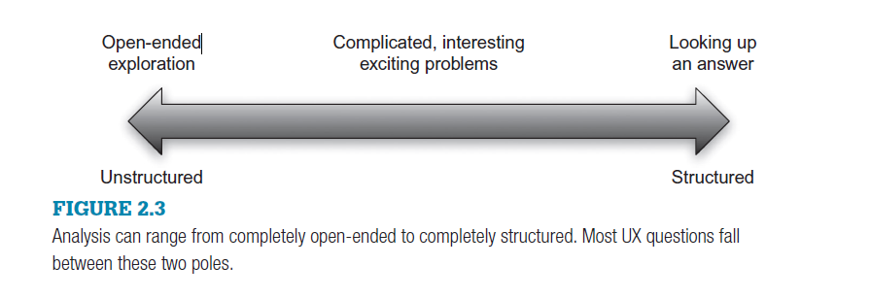

**Pose The Question**

Analysis starts with a question, with a gap in your knowledge that you wish to fill. The question sets boundaries on the activity, to let you know when you have accomplished your goal or to help you decide to quit because you are no closer to the goal. You start with the thing you want to learn—a “what” question like

* **“Where do users go after viewing the Our Services page?” or**
* **“What pages do users spend the most time on?” or**
* **“What are the categories of information that drive users to my website?”**
* **“why” question like “Why aren’t users clicking on this button” or**
* **“Why do so many users go to this page?”**

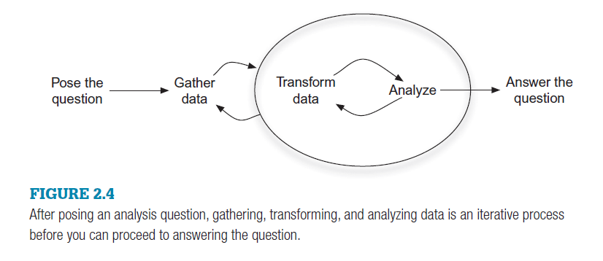

**Gather Data**

In this stage you gain access to the data source or sources that will meet your needs and gather the data from the appropriate tools. For a small-scale question using data in Google Analytics, gathering data may be as simple as navigating to the right report.

At the other extreme, you may use a script to download thousands of rows of data or get your hands on other sources like a customer relationship management (CRM) system or call-center report.

**Transform Data**

As with the gather data stage, for a simple inquiry there may be no transformation at all—you’re simply looking up a piece of data in a standard report in the interface of your web analytics tool.

More likely, though, you will transform the data in some way. You may combine disparate data into a

single table, sort or filter through a data set to get the subset that you need, or derive a metric by combining two of the metrics that your web analytics tool produces.

you may do multiple iterations of transformation and analysis.

**Analyze**

The goal of analysis is think about and interpret the data that you have gathered and transformed. It may be that you can tell a simple story from the data, but it is likely that you will find you have to go back and transform the data further as you find things that you need to clean or the transformation

you rendered doesn’t quite grant the insight that you need. You may also find that you have to go back to gather more data to complete the picture

**CONTEXT MATTERS**

Context is essential for understanding any of the data because no number, in isolation, is meaningful. Adding context means:

■ Comparing data between pages or between users of the same website.

■ Comparing data over time.

■ Looking at proportions rather than raw numbers.

■ Sometimes web analytics data will appear to contradict findings from other user research methods. Don’t automatically discard your finding, but try to find a new way to understand it or add nuance.

**DATA COLLECTION**

**Clickstream Data**

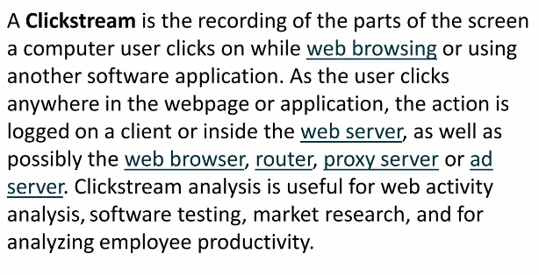

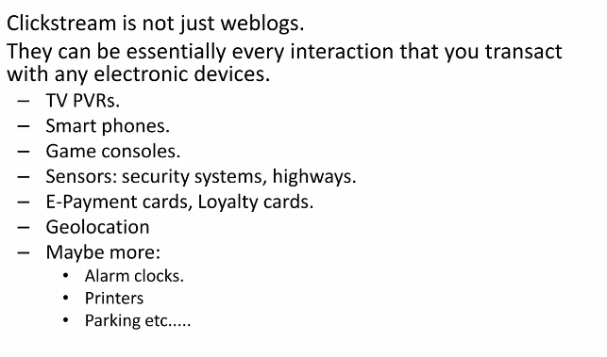

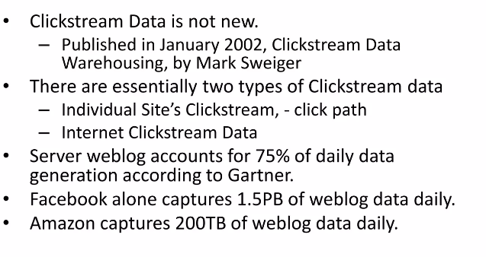

**Web Analytical Data is also known as Clickstream Data**.

There are four main ways that this sort of data is captured,

* Web logs,
* Web beacons,
* JavaScript tags,
* Packet sniffing.